**Database Management System Lab**

1. **Steps of installing Oracle 21c.**

**i)** Go to [Oracle Database Software Downloads](http://www.oracle.com/pls/topic/lookup?ctx=javase9&id=database_software_downloads" \t "_blank) in your browser.

**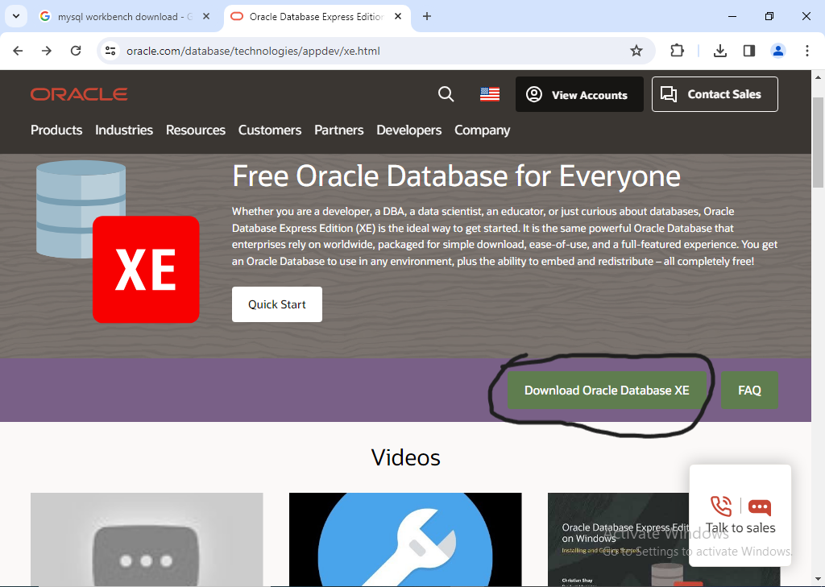**

**ii)** Download the 64-bit .zip file. Select the.zip file and right click to select “Extract All”. Extract both the .zip files to the same folder.

**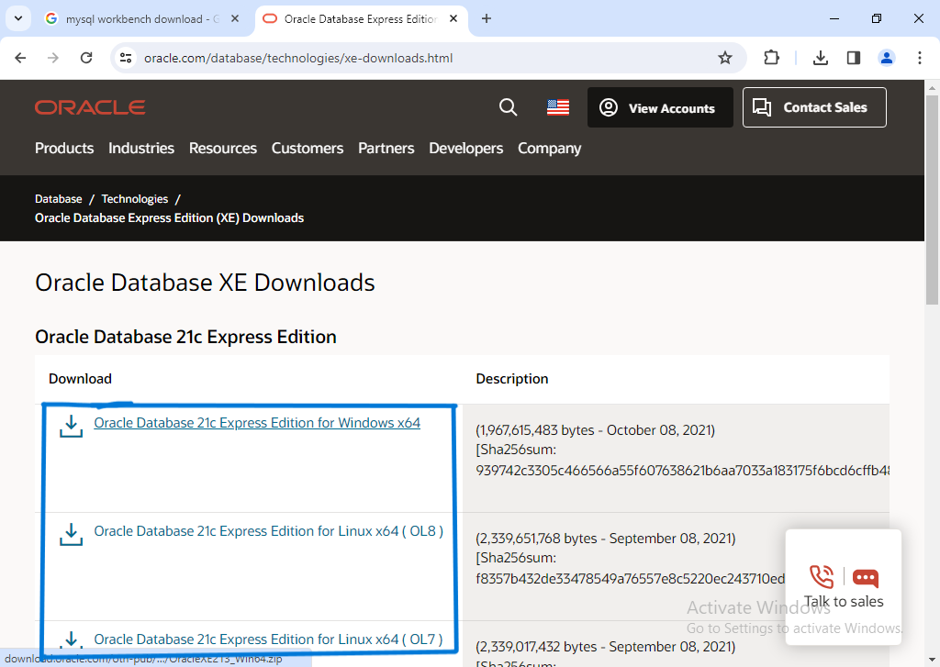**

**iii)** Run the setup.exe and select the installation options according to your database and Windows user requirements.

**iv)** Click “Install” to install the product. Oracle Database is installed on Windows.

**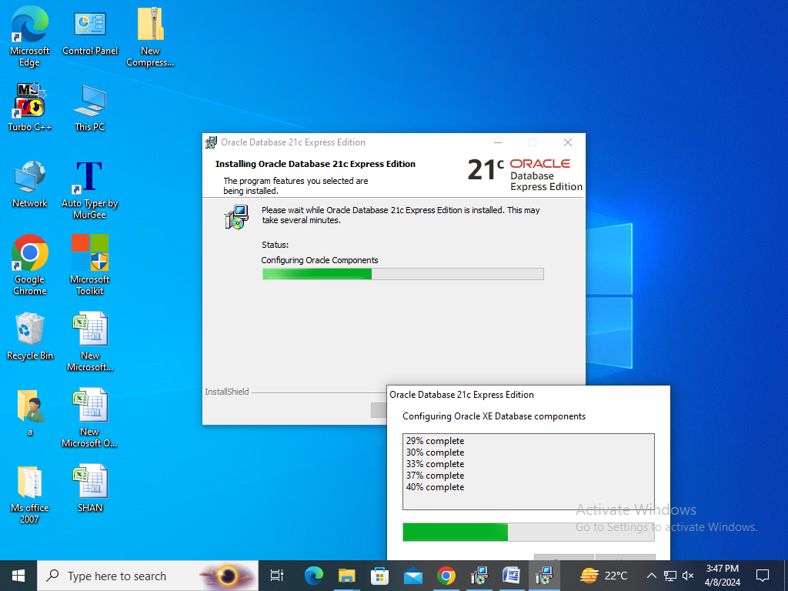**

Hold to complete the process.

**v)** Start the SQL Plus application.

**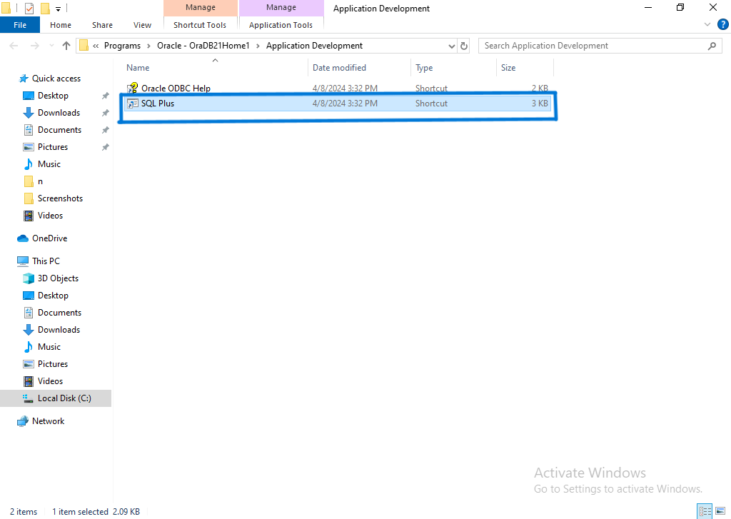**

From Windows **Start**->click **Programs**-> Oracle-*OraDB21Home1*->**Application Development**-> **SQL Plus**.

**